## Merchant Name: Siteline Implementation POC: Royce *(IM to fill)* CX POC: *[IMP to Add]*

### 

| Notes Sections   *(AE to fill if they have, Implementation to be completion DRI on handoff)*   * Info on how merchant bills   **Invoicing Process Today**: Contracts are generated through Quoter (being replaced by S-Docs), with manual handoffs into **QBO** and **Bill.com**. Bill.com is used for AR, but the CS team manually manages collections in spreadsheets.  **Customer Segments**: Siteline serves **a mix of SMB, mid-market, and enterprise clients**, with deal sizes ranging from $7K to over $100K.  The bill annually, quarterly, or monthly for a flat fee thats determined by a quantity in the contract. No usage  1) What is the merchant temperament?  Siteline is **pragmatic, time-conscious, and ROI-focused**, particularly around **RevOps and Finance efficiency**. Ari Goldstein (Head of Growth & RevOps) is analytical and solution-oriented—he's not tied to their existing setup and is open to change if it delivers automation and saves time. However, leadership (CEO Gloria) is **pricing-sensitive** and will only greenlight a solution if the cost-benefit is clearly justified. Ari is collaborative and well-aligned with cross-functional needs (Salesforce, CS, Finance), but will need internal consensus before moving forward.  Ari will be our main user and champion. Gloria will be involved - fair warning sh’s very smart and a tough cookie. Very in the weeds with product as a former Stripe PM from the early days  3) What are the Tabs features that the key POC cares about?  **Salesforce Integration**: Must be able to **ingest quotes from contracts**, sync billing contacts, products, and payment statuses back to Salesforce.  **Automated Collections**: Ari is focused on **reducing DSO** and wants to automate follow-ups, reminders, and visibility for CS into unpaid invoices.  **Flexible Product Handling**: Needs Tabs to handle **100+ SKUs**, tiered pricing, ramped contracts, and opt-out logic in revenue schedules.  **Reporting & Syncing**: Values Tabs' ability to **automatically generate ARR/revenue schedules** and **sync them back to QBO and Salesforce** cleanly.  **Time & Cost Savings**: Strong interest in avoiding a **custom-built solution**, minimizing lift from his team, and proving ROI to his CEO. |
| --- |

### Billing model *(Entire Section: Implementation to fill section)*

* Are there unique things about the customer creation process for this merchant?
* Information on how merchant bills
* How contract is broken up
* One off things to know about the merchant

### Contract Processing Steps *(Entire Section: Implementation/Success to fill Post-Go Live)*

* **General**
  + Implementation fees will be one-time, flat BTs
* **Item name** 
  + Listed in the Item column
  + Example:
    - Item Name: “Siteline Software - Unlimited User Access”
    - Item Description: “Software to manage pay applications, lien releases, and other compliance documentation.”

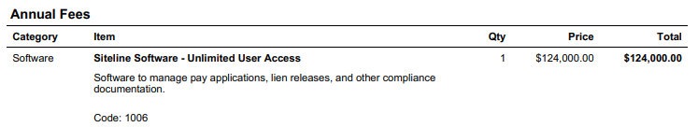

* **Integration Mapping:**
  + [**Here**](https://docs.google.com/spreadsheets/d/1DKhtMIpta13b8u9cftx3yy_C53mhoPq5fYi5DJ6zv68/edit?gid=1574523452#gid=1574523452)
* **Quantity:** use the listed ‘Qty’
  + Default to 1 if not listed explicitly
* **Price:** use the full listed price per item:
  + For One-Time Fees: use one-time subtotal
  + For Annual Fees: use full annual price per year - do not split unless contract specifies
  + If there’s a discount specify the discount on the BT
* **Net terms:** under ‘fees; payment’ section
  + Usually 30 or 15 days
* **Billing start date:** Listed under ‘terms’
  + **Annual Fees:** use contract start date for the term
  + **One-Time Fees:** use same start date (unless otherwise specified)
* **Service start date:** match billing start date for all items
* **Months of service:** use full service term based on contract:
  + Default to 12 months unless specified otherwise
* **Frequency:**
  + All recurring fees are billed annually unless contract states otherwise
  + Example of different cadence:

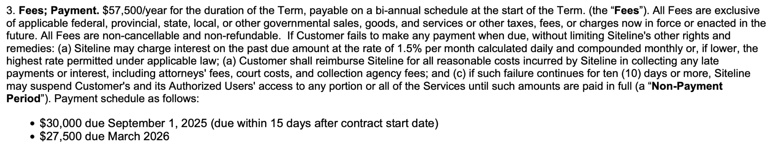

* + One-Time fees should have frequency = None
* **Special considerations:** 
  + Example below: Each product is revenue recognized per year, rather than added and divided by total years of agreement. This is consistent for all contracts for Siteline, pay attention to the "term".
* **Ignore:**
  + Ignore re-newals
  + Ignore payment failure penalties, renewal language, or data export fees unless explicitly quoted as a BT
  + Ignore Cost Breakdown section:

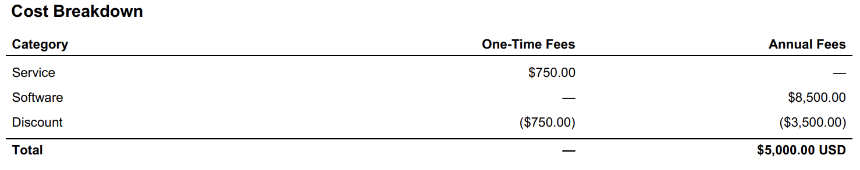

### Events Processing (if necessary) *(Entire Section: Implementation/Success to fill Post-Go Live)*

* Any important information on events billing

Integration Items Processing (if necessary)  
*(Entire Section: Implementation/Success to fill Post-Go Live)*

* What are the instructions for assigning integration items?
* Example: All Statsig integrations items should be labeled as “Sales”
* Example: All “Pinata” integration items should be labeled as “Software Subscription Bundle” unless otherwise noted by Merchant

Post Processing Communications (if necessary)  
*(Entire Section: Implementation/Success to fill Post-Go Live)*

* Does the Ops Team need to notify anyone on the team re: completion of processing batches in Implementation or Active phase?
* Who needs to be notified and when?
  + Example:
    - Who: Customer Success [Azmat Aziz] needs to be notified
    - Where: Messari internal merchant channel
    - When: contracts are processed [Merchant Phase: Active]

### Customer Information *(Entire Section: Implementation/Success to fill Post-Go Live)*

* Any important information on specifics customers of this merchant
  + Special memo’s certain invoices require
  + Invoice changes due to merchant/customer relationship

### Feature Requests *(AE to fill for all requests prior to Imp handoff, Imp to fill prior to go-live/Success to fill to fill Post-Go Live)*

* Filter accounts by CS rep
  + Want a permissions login for just CS to see only their accounts
  + Collections currently handled by CS
  + Medium
* Bubble Notifications in app in collections Kan Ban
  + Want red bubble notifications to see what’s changed on an invoice since last login
  + Drive action towards most important invoices
  + Medium

### Merchant Calls *(AE to fill for all videos prior to Imp involvement, Imp to fill prior to go-live/Success to fill to fill Post-Go Live)*

* Disco (6/12)
  + <https://us-56595.app.gong.io/call?id=8508479724547788326>
* Salesforce Demo (6/13)
  + <https://us-56595.app.gong.io/call?id=2036297432516039611>
* Tabs Demo, Intro to Gloria (6/26)
  + <https://us-56595.app.gong.io/call?id=4378704511722750136>
* Second Tabs Demo with Gloria (7/16)
  + <https://us-56595.app.gong.io/call?id=8689699007457424929>
* Commercial Conversation (7/31)
  + <https://us-56595.app.gong.io/call?id=1995859335266140623>